Closed Compound Words

🔹 What is closed compound word
# Source: AI Source: Provided by: [Data Path: Persons Table -> ID Column: 1, Name_En Column: Motasem Essam] -> From: [Chatgpt (GPT-4-turbo)] on [7/25/2025]
A closed compound word is a type of compound where two or more words are combined into one single word, with no spaces or hyphens between them.

✅ Definition:
# Source: AI Source: Provided by: [Data Path: Persons Table -> ID Column: 1, Name_En Column: Motasem Essam] -> From: [Chatgpt (GPT-4-turbo)] on [7/25/2025]
A closed compound is written as one word, even though it is made up of two (or more) individual words that have been combined to form a new meaning.

🔸 Examples of Closed Compound Words:
# Source: AI Source: Provided by: [Data Path: Persons Table -> ID Column: 1, Name_En Column: Motasem Essam] -> From: [Chatgpt (GPT-4-turbo)] on [7/25/2025]
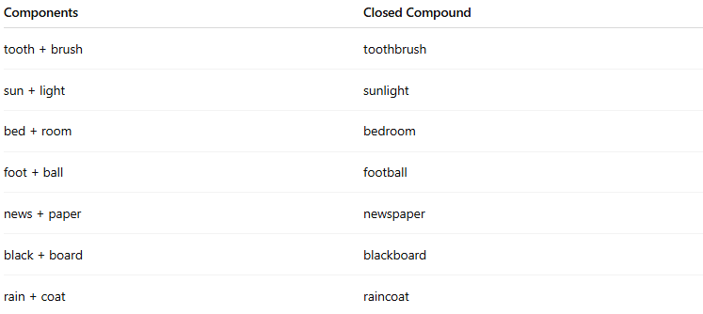
Components | Closed Compound
tooth + brush | toothbrush
sun + light | sunlight
bed + room | bedroom
foot + ball | football
news + paper | newspaper
black + board | blackboard
rain + coat | raincoat

🧠 Usage Notes:
# Source: AI Source: Provided by: [Data Path: Persons Table -> ID Column: 1, Name_En Column: Motasem Essam] -> From: [Chatgpt (GPT-4-turbo)] on [7/25/2025]
- Closed compounds are usually nouns, but can also be adjectives or verbs.
- Over time, many compounds evolve from open → hyphenated → closed forms as they become more common in usage.
Example:
- open: ice cream
- hyphenated: ice-cream
- closed: icecream (rare, but may happen with usage shift)

🆚 Other Types of Compound Words (for contrast):
# Source: AI Source: Provided by: [Data Path: Persons Table -> ID Column: 1, Name_En Column: Motasem Essam] -> From: [Chatgpt (GPT-4-turbo)] on [7/25/2025]

Type | Example | Format
Closed | notebook | One word
Open | post office | Two words
Hyphenated | mother-in-law | Linked with hyphen

📌 Summary:
# Source: AI Source: Provided by: [Data Path: Persons Table -> ID Column: 1, Name_En Column: Motasem Essam] -> From: [Chatgpt (GPT-4-turbo)] on [7/25/2025]
- Closed compound words are written as a single word.
- They combine two root words into a new unit of meaning.
- They are one of three main types of compound words.

